# SF2710 Filter Press Improvements

Table of Contents

SF2710 Filter Press Improvements 1

Summary 2

Problem 2

Potential Causes Identified 3

Cleaning Schedule and Procedures 3

Plate Material Incompatibilities with Process Chemicals 4

Uneven Cake Buildup 4

Most Likely Scenario 4

1. Toluene is attacking the plates and causing them to warp. 4

2. Improper cleaning of the filter cloths 5

Suggested Solutions 5

Source Filter Plates in Different Materials 5

Establish Better Cleaning Procedure 6

Cost-Benefit Analysis 6

Material Cost 6

Labor Cost & Safety 6

## Summary

The plates on SF2710 have a problem with warping. For troubleshooting we went through the manuals, talked to Operations, and talked to Moody Price through our representative Rhett Crain. We determined the most likely problem is that the toluene present in the slurry that goes through the press is damaging the plates. We have gotten some quotes back on different plate materials and are looking at purchasing a set. The people who worked most closely on this are Daniel Dragland, Nicole Stein, Patrick Herke, Avery Eggart, and Joe Haley.

## Problem

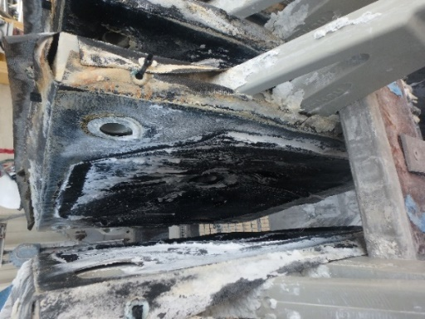 The filter press plates warp within 3-5 months and need to be changed out for the filter press to continue functioning. The quality of filtration provided by the press starts dropping off as the plates warp. The 3-5 month time period is where it gets so bad that the plates need to be changed.

Figure 1 Figure 6 Additional image showing bowing of the plates. Picture taken ~1 week prior to plate swap.

S:\MAINT\Co-op & Intern Folder\Patrick Herke\SF2710 Improvement\images after cleaning 6-10-2021\P6100007.JPG

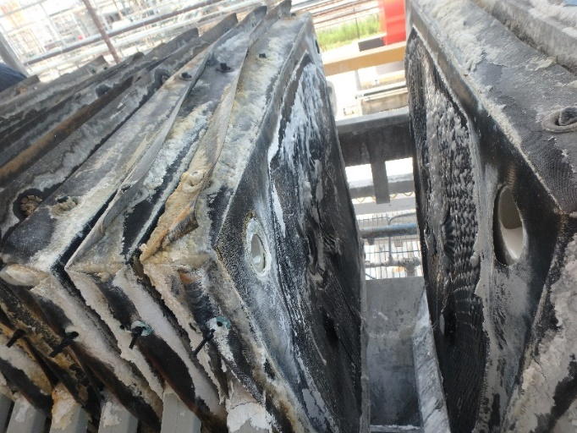

Figure 2 Roughly middle of stack. Shows plates bowing inward towards the center. Most visible by looking at top edge of plate. Picture taken ~1 week prior to plate swap.

S:\MAINT\Co-op & Intern Folder\Patrick Herke\SF2710 Improvement\images after cleaning 6-10-2021\P6100006.JPG

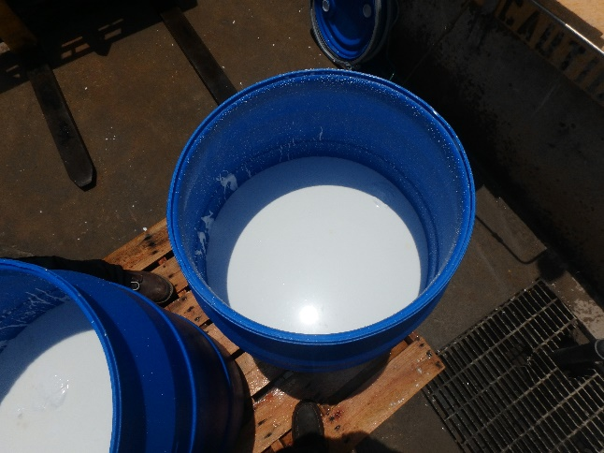

Figure 3 Cake material from filter press with high liquid content. Picture taken ~1 week prior to plate swap.

S:\MAINT\Co-op & Intern Folder\Patrick Herke\SF2710 Improvement\images after cleaning 6-10-2021\P6100020.JPG

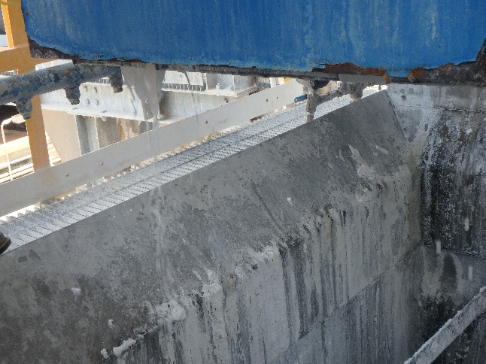

Figure 4 Leaking of filter press. Picture taken ~1 week prior to plate swap.

S:\MAINT\Co-op & Intern Folder\Patrick Herke\SF2710 Improvement\images after cleaning 6-10-2021\P6100016.JPG

As the plates warp the filter press begins to leak and the cakes that are left behind contain higher liquid content. The slurry also begins to bypass the filter cloths. When it was opened to clean on June 10, 2021, we saw slurry in the filtrate drainage holes. Our best guess is that the warping of the plates results in there being a path along the sealing surfaces of the plates to the filtrate drainage holes. This would allow the slurry to skip going through the filter cloth.

## Potential Causes Identified

### Cleaning Schedule and Procedures

When examining the plates following cleaning on June 10, 2021, we saw there was slurry in the filtrate drainage holes that was dripping down onto the sealing surface. This could interfere with the seal.

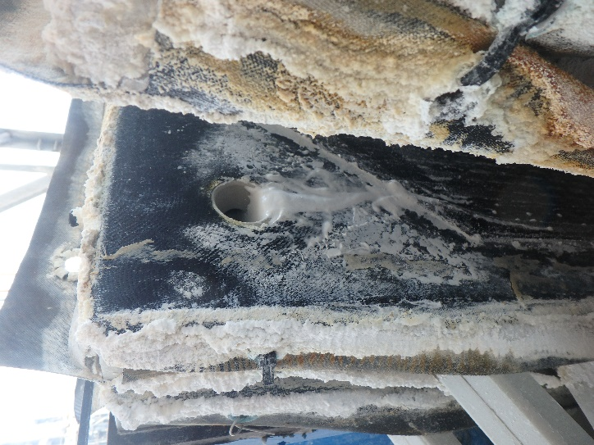

Figure 5 Slurry still in filtrate drainage hole after plates have been cleaned. Slurry material on plate sealing surfaces. Picture taken ~1 week prior to plate swap.

[S:\MAINT\Co-op & Intern Folder\Patrick Herke\SF2710 Improvement\images after cleaning 6-10-2021\P6100012.JPG](images%20after%20cleaning%206-10-2021/P6100012.JPG)

When Operations opens the filter press to remove the cakes, they scrape off any cake buildup that sticks to the plates/cloths. They do not, however, clean the cloths by any other means when they start becoming blinded. The only time the filter cloths are changed out is when the plates are changed out. Filter cloths should be cleaned or changed as soon as they start blinding. Otherwise, their filtering ability decreases, and uneven pressure differentials can start to develop due to uneven cake buildup.

Standard cleaning methods for the filter cloths according to the manual include:

* a high pressure wash using water
* recirculating a particulate dissolving solution within the press
* removing the filter cloths and soaking them in a particulate dissolving solution

### Plate Material Incompatibilities with Process Chemicals

Statement from the Operations team on the chemical makeup of the slurry passing through the filter press:

The aqueous solution is generally about 3-5 wt% sodium hydroxide (caustic) in water. This material is saturated with toluene, so the aqueous material contains about 500 ppm toluene. The solids being filtered are deactivated aluminum hydroxide solids. Because we have two phases of material in the tank pumping to the press, there is potential that more toluene solvent could be introduced to the press if the levels in the tank get off, so when investigating alternate materials, it would be good to assume that these plates may see as much as 1 wt% toluene.

### Uneven Cake Buildup

Uneven cake buildup can result in pressure differentials across plates. This can then cause the plates to warp or even break. Uneven cake buildup could be due to a number or reasons.

The reasons include:

* Flow rate that is too fast or slow for the filter press
* Blinding of the filter cloths
* Warping of the plates due to other reasons

## Most Likely Scenario

There are likely two problems occurring.

### Toluene is attacking the plates and causing them to warp.

Statement from engineers at Moody Price on effects of Toluene on Polypropylene plates:

Polypropylene (PP) Filter Plates are susceptible to chemical attack by any slurry containing hydrocarbons, such as Toluene. The attack takes place in the form of absorption. PP will absorb hydrocarbons from the slurry, which causes two problems. One, the PP material will become softer, losing tensile strength. Second, the PP material will swell. The swelling is what causes the plates to bow. The center web, being thinner in cross section than the periphery, will swell at a faster rate which causes the webs to bow. Temperature accelerates this process. If pressure differentials are present, as the PP material has lost a significant amount of its physical properties, increased deflections in the web are likely. Additionally, as the webs bow (from swelling or pressure differentials) thick and thin cakes are developed which lead to increased pressure differentials. Once the process begins, it just continues at an exponential rate.

The rate of attack depends on the amount of hydrocarbon material in the slurry and the operating temperatures.

Even very small amounts of hydrocarbons present, can affect the PP material over longer periods of time.

This will occur even if there are no pressure differentials present, the plates will still warp and bow due to the swelling from the chemical attack.

The chemical resistance for PP with Toluene has a limited temperature resistance at 20C and no resistance at 60C.

[Chemical Resistance Chart | Plastics International (plasticsintl.com)](https://www.plasticsintl.com/chemical-resistance-chart)

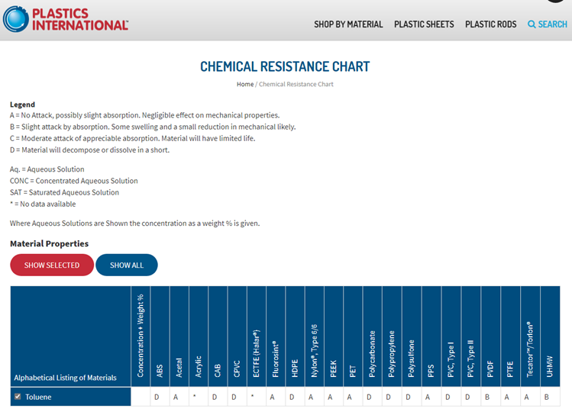

### Improper cleaning of the filter cloths

When the filter cloths begin to blind, they need to be cleaned or changed in order to prevent uneven cake buildup and maintain flow rates. This is currently not happening.

Material buildup on the sealing surfaces is also visible which can result in leaks and warping.

## Suggested Solutions

### Source Filter Plates in Different Materials

Submitted a request for Moody Price to ask their suppliers about other material options that could handle toluene better than polypropylene.

Quotes

1. 30% GF Nylon (~$65,000)



1. PVDF (~$100,000)

<Insert Link to PDF of quote>

### Establish Better Cleaning Procedure

Emphasize importance of making sure the sealing surfaces are completely clear of any slurry or other debris.

Establish a protocol for when and how to clean and when to replace the filter cloths.

Filter cloths should be cleaned or replaced as soon as they start blinding. One way this could be defined is when the filter press drops below a set flow rate. An electronic indicator for flow in lbs/hr exists on the filter press and is hooked into PI process book.

Standard cleaning methods for the filter cloths include:

* a high pressure wash using water
* recirculating a particulate dissolving solution within the press
* removing the filter cloths and soaking them in a particulate dissolving solution

[Chemical Cleaning of Filter Cloth for Optimal Filter Press Performance (micronicsinc.com)](https://www.micronicsinc.com/filtration-news/chemical-cleaning-filter-cloth/)

## Cost-Benefit Analysis

### Material Cost

* Current material:
  + Polypropylene: ~$80,000 over the last 3 years
    - 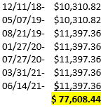Plates are ~$12,000 per set

Figure 6 Dates on which the filter plates were changed over the last 3 years.

* New material:
  + 30% glass filled nylon: ~$65,000 per set
  + PVDF: ~$100,000 per set

On a 3-year time scale we could save ~$15,000 on the plates themselves by switching to nylon plates. PVDF plates would only cost us an additional ~$20,000 beyond what we already spend. In addition, the plates are not supposed to be a consumable item and so should last much longer than the 3-year time frame considered here. To illustrate this the following is the recommended spares list from the manual, which does not include plates.

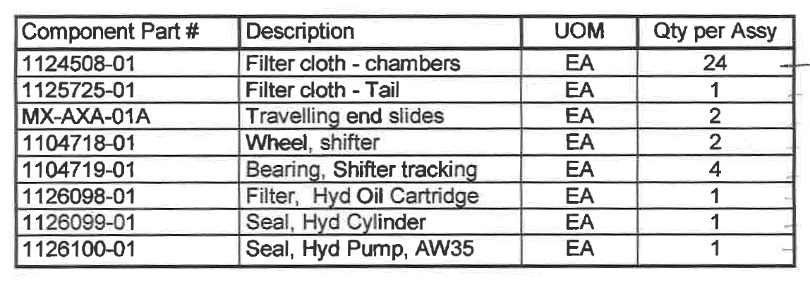

Figure 7 Recommended spare parts for the filter press from the manual.

### Labor Cost & Safety

On average the operators go up and change out 26 plates once every 3-5 months. This requires two people to be able to lift and move the plates and consumes a large portion of their day. The plates weigh about 30lbs each and they need to be removed from the filter press and then brought down to ground level. (The 30lbs is a rough estimate based on the volume of the plate and the density of polypropylene. In calculating the volume, I took into account the fact that the middle of the plate is thinner than the edges.) They remove the plates from the press by hand and often have trouble getting them out due to how warped they are. I do not know if they carry the down the stairs or if they have some other method.

If the material of the plates were changed, they’d periodically need to replace just the filter cloths rather than the whole plates. This would both save time and eliminate a significant source of potential injury.

## Next Steps

1. Perform a more detailed economic analysis. This should include labor costs.
2. Scope out a capital project to purchase a complete set of nylon plates.
3. Establish a new protocol dictating when and how to clean the filter cloths and plates, and when to replace the cloths. Refer to the section “Establish Better Cleaning Procedure” of this document and pages 47-52 of the filter press manual which are attached under “Additional Resources” for more information.

## Additional Resources

Contains the sections: Filter Plates, Filter Cloths, and Maintenance Schedule from the portion of the manual that covers maintenance of the filter press.



Email discussion with Moody Price about problem and quotes

 

Images of plates on July 10, 2021 after cleaning and ~1 week before they were swapped out.



Data on the dimensions of the filter press plates that we collected to send to Evoqua in order to get a quote from them.

   

|  |  |
| --- | --- |
|  | SKU |
| Head Plate 1 Button | 9207618 |
| Tail Plate 1 Button | 9207619 |
| Intermediate Plate 1 Button | 9207620 |
| Intermediate Plate 3 Button | 9207621 |

Images of plates and filter press on June 20, 2021. Taken to accompany dimension data sent to Evoqua.

